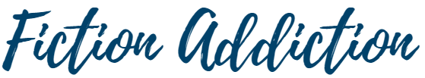
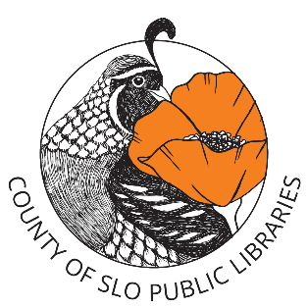
January 3rd Sandwich, Catherine Newman (place hold)
February 7th Nine Perfect Strangers, Liane Moriarty (kit)
March 7th Book Lovers, Emily Henry (place hold)
April 4th TBD—Cuesta Book of the Year
May 2nd Tomorrow and Tomorrow and Tomorrow, Gabrielle Zevin (place hold)
June 6th The Thursday Murder Club, Richard Osman (kit)
July 11^{th* (changed due to holiday)} 13 Ways of Looking at a Fat Girl, Mona Awad (kit)
August 8^{th* (also changed)} The Overstory, Richard Powers (kit)
September 5th Remarkably Bright Creatures, Shelby Van Pelt (place hold)
October 3rd Malibu Rising, Taylor Jenkins Reid (place hold)
November 7th The Rosie Project, Graeme Simsion (kit)
December 5th Discussion of Favorite Books of the Year

First Saturday of the Month | 9am-10am
Currently held at the San Luis Obispo Library

2026 Book List

